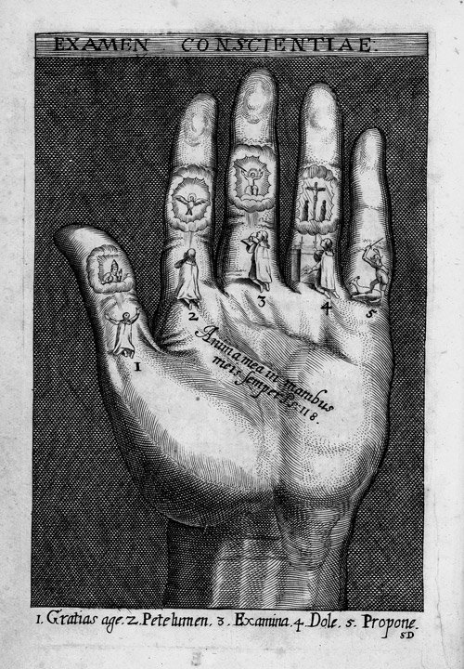 | The Examen  Anima mea in manibus mei semper  My spirit is always in my hands  Psalm 118:109  1 Gratias age (give thanks)  2 Pete lumen (ask for light)  3 Examina (examine)  4 Dole (be sorry)  5 Propone (resolve)  St Ignatius Loyola (1491-1556)  Spiritual Exercises (edition Antwerp 1620)

